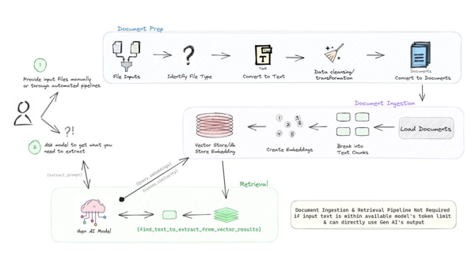

1. Input as a PDF from local machine.
2. Create a streamlit based UI to get the questions from the user based on LLM
3. Read the PDF, Convert the PDF to text.
4. Make multiple modules of the text (Create small text chunks)
5. Save the text in vectorDB.
6. Query the vectorDB based on the question asked by the user.
7. Find relevant text chunk and answer the question.